**Incident Documentation:**

**Summary**

The caller reported that PO 409089 shows cancelled and cannot be received in.

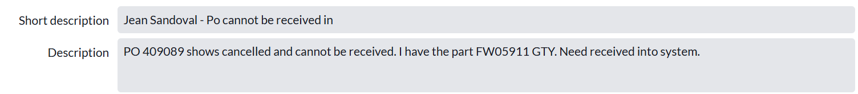Shape

**Initial Investigation**

* Based on the information provided by the caller. We couldn’t filter out the exact data.
* With the location number (04279) that was provided by the caller, we were able to find information on the cancelled status.

Queriesused for investigation: 

**Step 1:** Verify the cancelled status in ESL_Reporting database  
SELECT *  
FROM [ESL_Reporting].[Inventory].[PurchaseOrder] po (NOLOCK)  
JOIN [Inventory].[PurchaseOrderDetail] pod (NOLOCK) ON pod.PurchaseOrderID = po.ID  
JOIN [Common].[Location] loc (NOLOCK) ON loc.ID = po.LocationID  
JOIN [Common].[Item] itm (NOLOCK) ON pod.PartOrderedID = itm.ID  
WHERE po.PurchaseOrderNumber = '409089'  
AND loc.LocationNumber = '04279'



Status 9 means Cancelled.

**Step 2:** Verify the cancelled status in WMS_Reporting database  
SELECT *  
FROM [WMS_Reporting].[Inventory].[TransferOrder] tom (NOLOCK)  
JOIN [Inventory].[TransferOrderLine] tod (NOLOCK) ON tod.TransferOrderGUID = tom.GUID  
JOIN [Common].[Location] loc (NOLOCK) ON loc.ID = tom.DestinationLocationID  
JOIN [Common].[Item] item (NOLOCK) ON item.ID = tod.ItemID  
WHERE tom.RetailPurchaseOrderNumber= '409089'  
AND loc.LocationNumber = '04279'



TransferOrderStatus 5 means Cancelled.

**Step 3:** Verify the cancelled status in Koerber database

Instead of using PO number, we use Order number provided by the query in Step 2 (GT5516807)  
select status,*from t_order (nolock) where order_number='GT5516807'



The status shows cancelled.

**Resolution:**

Since all the internal orders were cancelled across all systems so we can't open one up to receive it. One will have to manually adjust the part in.

Updated the same to the caller.

